**PISTON CUP ROLL CAGE SPECIFICATION SHEET**

SCHOOL NAME ________________________

TEAM NAME __________________

CAR NUMBER ______________ (to be filled out when you arrive for competition)

**NOTE**: **This sheet MUST be completed and submitted by the competition rules. Failure to do so will result in a penalty.**

**PURPOSE:** **The purpose of this sheet is to facilitate verification of the proper fuel system and to provide a safety standard for the competition events**.

1. Academic year the cage was constructed? ___________________________

2. Material Type (i.e.: 4130): _________________OD: _________________ Thickness: _________________

3. Primary Welder: _________________________

Welding Method Used: ____________________________

Type of Filler Material: ____________________

Shielding Gas Used: _____________________________

4. Equivalency calculations if needed (attach to this sheet).

5. All welds and/or other attachment methods must be checked for integrity. Faculty advisor and team captains are requested to do destructive testing on sample joints that represent the integrity of similar welds on their frame.

6. Have any welds been grounded/sanded or modified? ___________

7. Maximum length of straight members: _______________

8. Maximum bend of bend members: __________________

9. Are all junctions of Primary and Secondary members between 51 mm of the Named Point? _____________

10. Minimum wall thickness of Secondary members: _______________

11. Minimum outside diameter of Secondary members: _____________

12. Minimum length of Lateral Cross members: ___________________

13. Width of RRH measured 686 mm (27 in.) above the inside seat bottom: ___________________

14. Are all vertical members continuous tubes: ____________________

15. Distance of top and bottom intersections of LDB and RRH vertical members from points A and B: ____________________

16. Angle between LDB and RRH vertical members: _________________

17. Distance of Points CR and CL forward of the intersection of the RHO members and a vertical line rising from the aft of the seat bottom: _________________

18. Height of points CR, CL, BR and BL above the seat: __________________

19. Lengths of SIM members above the inside seat bottom: ________________

20. Are the feet of the driver behind the plane defined by points FR, L and DR, L? _______________

21. Are all FBMs continuous tubes? _________________

22. Angle between FBMUP and the vertical: __________

23. Are the total weld lengths of all gussets two times the tubing circumference? _____________

24. Maximum length of members for FAB systems: _________________

25. Triangulation angles (projected to the side view) between members: ____________________

26. Distance of the intersection of the Front Systems of FAB with the FBMUP members from the centerline of Point C

27. Do the rear systems of FAB create a structural triangle? ______________

28. Are the members of this structural triangle continuous? ______________

29. Distances of the rear system FAB from Points B, S and A on each side of the vehicle: _______________

30. Angle of members connecting to Point A: __________________

31. Length of LC joined to the aft vertex of each rear bracing triangle: __________________

32. Are welded roll cage member tubes at an angle of greater than 5 degrees reinforced with a welding sleeve? ___________

33. Are the lengths of all sleeves two times the diameter of the tubes being reinforced? ________________

34. Diameter of holes for rosette welds: _______________

35. Length of linear weld to secure the sleeve inside the joint: _______________

36. Has each team member who has made any welding joint on the roll cage submitted two welding samples using the same material and processes as the roll cage welds? ___________________

37. Does the material used for Primary Roll Cage Members and bracing meet the requirements outlined in Section B.3.2.16? ______________

38. Is the documentation of equivalency complete? _________________

39. Clearance of driver’s helmet: _________________________

40. Clearance of driver’s shoulders, torso, hips, thighs, knees, arms, elbows and hands: __________________

41. Clearance of driver’s helmet from members at the top of the roll cage: ____________________________

42. Is the entire vehicle free from any and all sharp edges? _____________________

43. Do the bolted roll cage joints follow the requirements outlined in Figure B-23? _____________________

44. Are all drilled members reinforced with a weld-in sleeve according to Figure B-24? ___________________

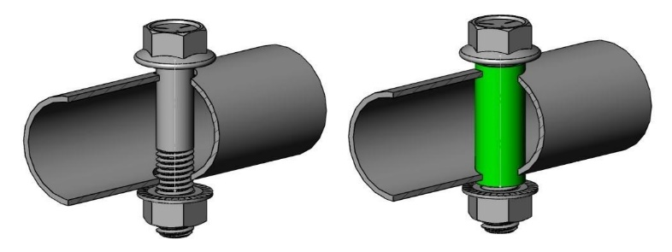

**Figure**



**B**



**-**



**24**



**:**



**Roll Cage,**



**Required sleeve for drilled holes**



45. Is the Roll Cage Documentation Package complete according to Section B.3.7.1? _____________________

46. Has the Roll Cage Documentation Package been uploaded according to Section B.3.7.2? ______________

Date of inspection _______________________________________________________

**NOTE: It is extremely important that such an inspection be made to ensure the welds have good penetration and joints are completely welded.**

**WE HAVE EXAMINED THE ABOVE INFORMATION AND TO THE BEST OF OUR KNOWLEDGE DEEM IT TO BE ACCURATE.**

TEAM CAPTAIN __________________________________________ (SIGNATURE) _____________ (DATE)

FACULTY ADVISOR __________________________________________ (SIGNATURE)

_____________ (DATE)